1. Deploy Bridge and ERC20Handler Contract on Binance, Verify and Configure.

Here, the parameters are currently base on Binance Smart Chain.

1. Bridge Contract

Compiler version: 0.64

Source code:

[https://github.com/vitalikvaraksa/avaBscCross/blob/master/solidity/lockMint-lockMint/Bridge.sol](https://github.com/vitalikvaraksa/avaBscCross/blob/master/solidity/lockMint-burnRelease/Bridge.sol)

Parameter: 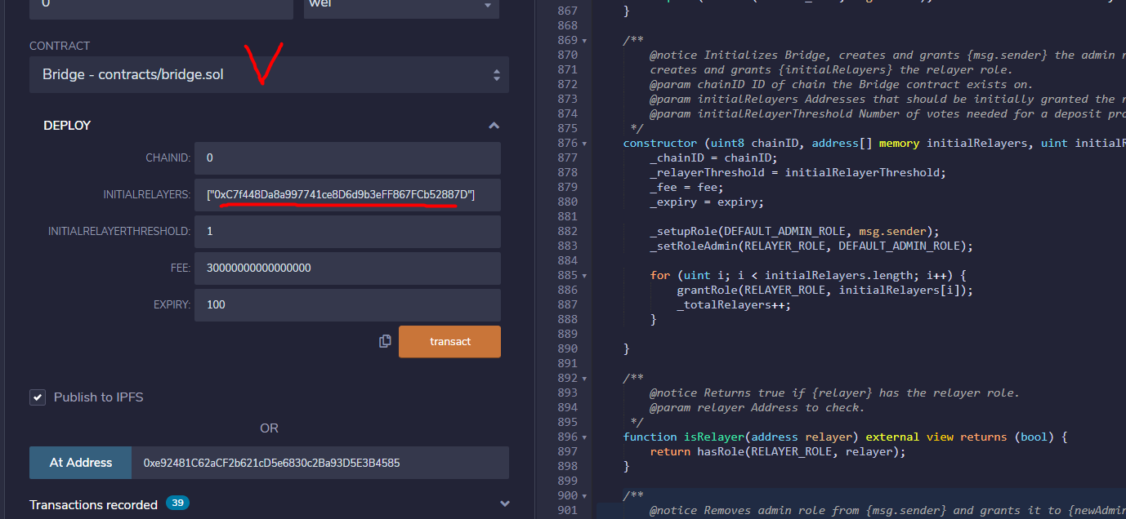

Set the parameters like above. INITIALRELAYER: wallet address that will be used for relayer.

1. ERC20Handler Contract

Compiler version: 0.64

Source code:

https://github.com/vitalikvaraksa/avaBscCross/blob/master/solidity/lockMint-lockMint/ERC20Handler.sol

Parameter: 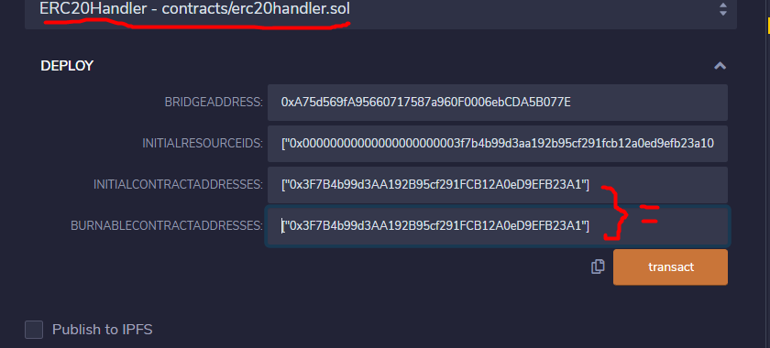

BRIDGEADDRESS: bridge contract address on Binance

INITIALRESOURCEIDS: array of resourceids on Binance, token resource id can be one element of this array.

INITIALCONTRACTADDRESS: array of contract address on Binance, token address can be one element of this array, e.x OPUS token

BURNABLECONTRACTADDRESSES: array of contract address that will be burnable

1. Verify them with details of above
2. Configure on Bridge contract

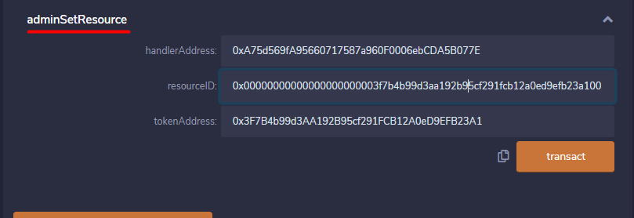

handlerAddress: ERC20Handler Contract address

resourceID: OPUS token resourceID (IT WILL BE SAME ON ALL CHAIN)

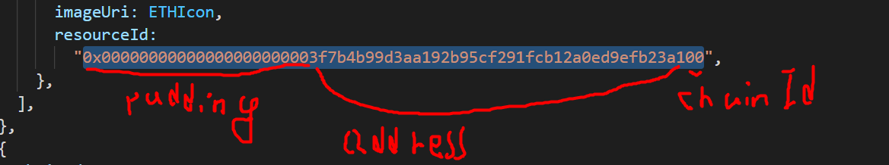

tokenAddress: OPUS token address

1. Give mint privilege to ERC20Handler contract

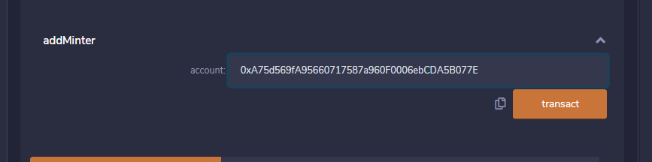

Account: ERC20Handler contract address

1. Deploy Bridge and ERC20Handler Contract on Avalanche, Verify and Configure.

Here, the parameters are currently base on Binance Smart Chain.

1. Bridge Contract

Compiler version: 0.64

Source code:

<https://github.com/vitalikvaraksa/avaBscCross/blob/master/solidity/lockMint-lockMint/Bridge.sol>

Parameter: 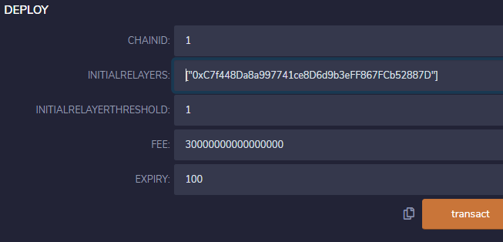

Set the parameters like above. INITIALRELAYER: wallet address that will be used for relayer.

1. ERC20Handler Contract

Compiler version: 0.64

Source code:

https://github.com/vitalikvaraksa/avaBscCross/blob/master/solidity/lockMint-lockMint/ERC20Handler.sol

Parameter: 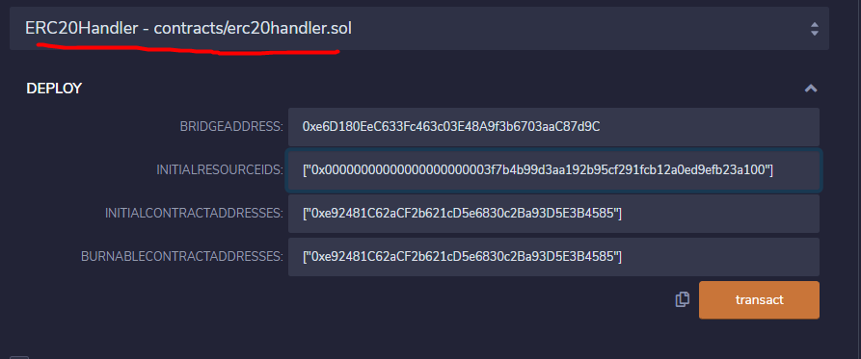

BRIDGEADDRESS: bridge contract address on Avalanche

INITIALRESOURCEIDS: array of resourceids on Avalanche, token resource id can be one element of this array.

INITIALCONTRACTADDRESS: array of contract address on Avalanche, token address can be one element of this array, e.x OPUS token

BURNABLECONTRACTADDRESSES: array of contract address that will be burnable

1. Verify them with details of above
2. Configure on Bridge contract

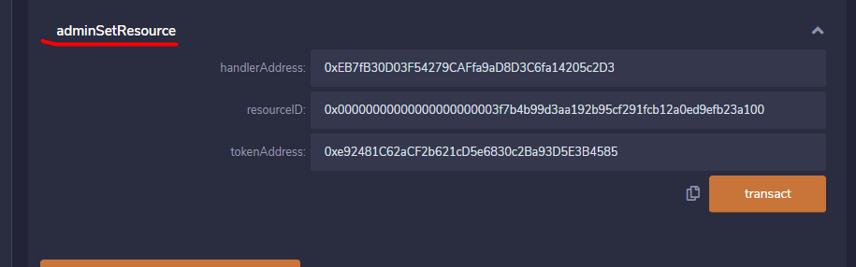

handlerAddress: ERC20Handler Contract address on Avalanche

resourceID: OPUS token resourceID



tokenAddress: OPUS token address on Avalanche

1. Give mint privilege to ERC20Handler contract

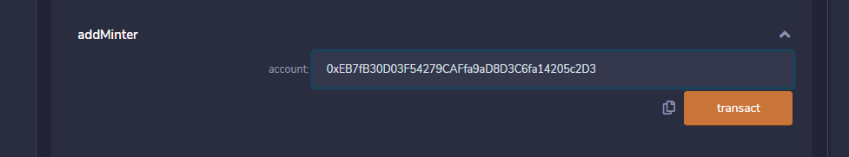

Account: ERC20Handler contract address on Avalanche